+91 7488835231



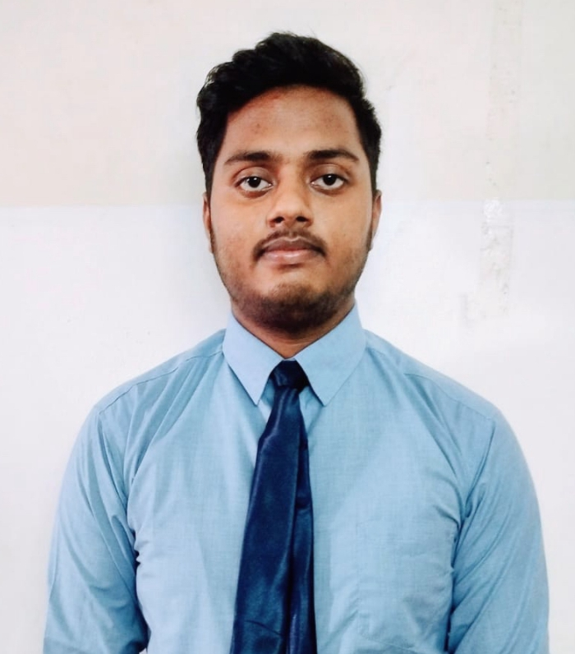

1 77777 66666

PREM AMAN

linkedin.com/in/premaman

amanprem374@gmail.com



Ranchi, Jharkhand



github.com/premaman



**SUMMARY**

Logical and organised individual with a strong foundation in software engineering. Seeking to raise coding KPIs by providing error-free codes. Ability to translate business requirments into innovative software solutions.

.

**TECHNICAL SKILLS**

Web Development (FE)

Programming With Python | C,C++ | mySQL | Java

KOTLIN

OS : Windows, Linux, Unix, and MacOS

**CERTIFICATIONS**

**LinkedIn Certificates**

AISucceeding in Web Development: FS and FE

Getting started with AI and Machine Learning

STC on Intelligence for the Digital Age

**Technocean:**

AR/VR/Game Design workshop(Technocean)

Powering AI and Analytics using SAS tools (Technocean)

**POWER SKILLS**

Sociable and team player

Observant and hands on learner

Adaptable

**EXTRA CURRICULAR ACTIVITIES**

Inter School Quiz Competition

Inter Zone Kabaddi tournament. Feb 21

**PROJECTS**

**Income Tax Department (Website). Aug’22**

Optimize the website for Easy Accessible, Fast, Simple

For Everyone and optimize for all devices.

**Paper Piano (Electronic Project). Apr’23**

The Piano Is tuned by Software to produce different

sounds at different frequencies.

**Medicine Record Management System(C program). Apr’23**

This program is a simple patient record management

system. It allows the user to add new patient records,

view all existing patient records, search for a specific

patient record, and delete a specific patient record.

**Designing using Autocad. May’23**

Gain proficiency in creating technical drawings, 2D and

3D models, and understanding the application of CAD

software in design.

**ACHIEVEMENTS**

2 Star Rating in Python on HackerRank

3 Star Rating in C on HackerRank

**EDUCATION**

B.Tech. in Computer Science and Engineering Aug '22 - Present Lovely Professional University |Phagwara, IN

CGPA 8

Higher Secondary Apr '21 - Mar '22

M.B.DAV Public School|JHARKHAND, IN

Percentage: 82.0%

**LANGUAGES**

English

Hindi